Join Now!  If you are interested in law enforcement and want to learn about a career as a Police Officer.  The Morro Bay Police Explorers are looking for students between the ages of 14 and 20 to join our post. Interested candidates should inquire regarding eligibility.  ARE YOU READY?  (805) 772-6225  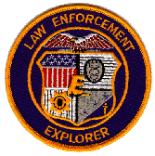 | Associated with the Boy Scouts of America  Exploring is a program devoted to career learning, development of life and leadership skills, and community service. Each Explorer post is based through local law enforcement agencies and sponsored by the Boy Scouts of America. Post 43 of Morro Bay is hosted by the Morro Bay Police Department is a current charter member of the Los Padres Council of the Boy Scouts of America. Post 43 is supervised by an adult advisor who is an employee of the Morro Bay Police Department.    Morro Bay Police Department  850 Morro Bay Blvd Morro Bay, CA 93442  Officer Maria Lomeli  Officer Will Marvos | Explorer Post 43  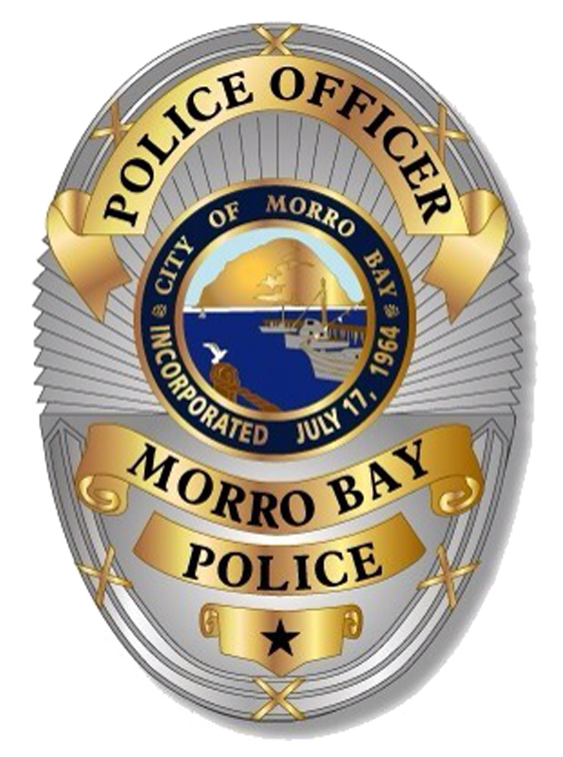  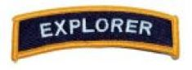
Police Explorers demonstrate their skills during annual competitions with other Explorer Posts.  EXPLORERS ASSIST AT CIVIC EVENTS  As part of our commitment to public service, Explorers assist at virtually every day sponsored event, such as the Fourth of July celebration, Thanksgiving community dinner, Caroling Cops and other community events.  Explorers also raise money by working at the Cruising Morro Bay Car Show and annual Harbor Festival.  Exploring isn’t just about training and service. Post 43 participates in yearly competitions against other Explorer Posts from law enforcement agencies across the state. These competitions allow our Explorers to “show off” what they have learned. Competition events include realistic law enforcement scenarios, judged by actual peace officers, and demanding physical challenges. | Post 43 subscribes to the Morro Bay Police Department vision of providing the highest level of police service in partnership with our community.  As such, Explorers are highly trained in many areas of law enforcement. This includes Law, Ethics, Tactics, Fitness, Community Service and much more.  Just some of the activities we do are:  - Training  - Community Service  - Competitions  - Ride-A-Longs  - Group Trips  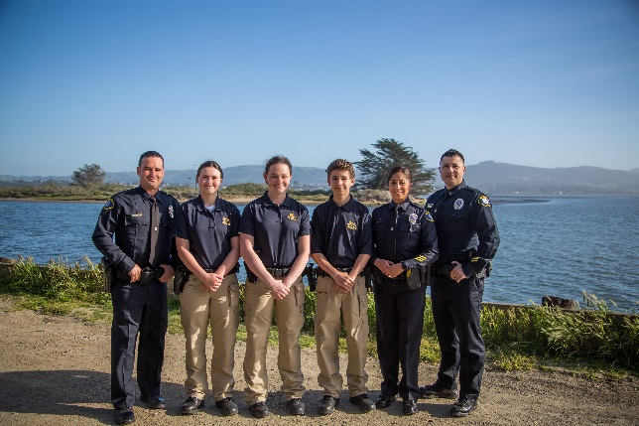 | Post 43 is structured much the same as its host police department, with an internal rank and command structure. Our post is supervised by an advisor and an associate advisor, which are MBPD veteran officers.  TEAMWORK AND PROFESSIONALISM  Our ideal, as started in our adopted Explorer Code of Ethics, is to develop the nearest generation of law enforcement personnel as character centered, service oriented individuals. We strive for personal growth, balance fun with discipline, and promote teamwork and professional behavior in our lives.  If you want to challenge yourself, and be in an environment which brings out your best, consider becoming a Morro Bay Police Explorer. Post 43 meets at Morro Bay Police Department at least twice a month.  Telephone: Officer Maria Lomeli or  Officer Will Marvos  (805) 772-6225  mlomeli@morrobay.ca.gov  wmarvos@morrobay.ca.gov

